NATIONAL UNIVERSITY OF COMPUTER AND EMERGING SCIENCES PESHAWAR CAMPUS

PROGRAMING FUNDAMENTAL LAB
LAB TASK 02
SAHIL ANWAR
22P-9141
SE-1A
INSTRUCTORS DETAIL
SIR USMAN
QUESTION O1
Write a program in c for converting the value of feet into inches?
#include <stdio.h>
int main()
{
int feet=8;
int inches=12;
int result;
result=feet*inches;
printf("convert feet into inches=%d",result);
return 0;
}
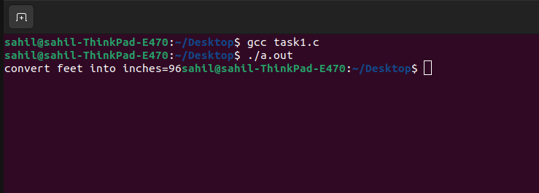
QUESTION 02
Write a C program that takes quantity in kilogram and convert into pounds.
#include <stdio.h>
int main()
{
int kilogram=16;
float pounds=2.20462;
int result=kilogram*pounds;
printf("convert kilogram into pounds=%d",result);
return 0;
}
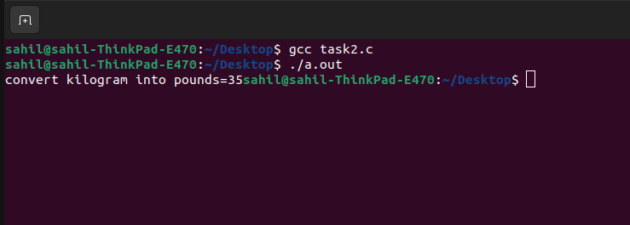

QUESTION 03
Write a program to compute the formula where the value was provided by the user.
#include <stdio.h>
int main()
{
int a;
int b;
int value;
printf("put the value of a\n");
scanf("%d",&a);
printf("put the value of b\n");
scanf("%d",&b);
value=a*a*a-b*b*b-3*a*b*(a-b);
printf("answer=%d\n",value);
return 0;
}
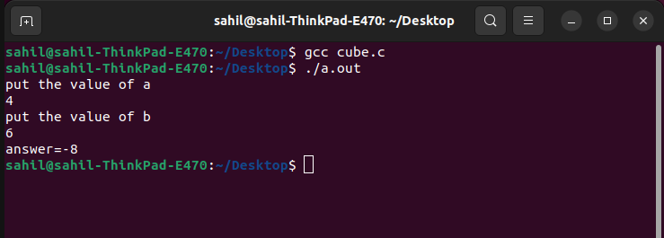

QUESTION 04
Write down a program that takes seconds from the user and displays the time in hours minutes and seconds format.
#include <stdio.h>
int main()
{
int hr,min,sec;
printf("enter the second=");
scanf("%d",&sec);
hr=sec/3600;
sec=sec%3600;
min=sec/60;
sec=sec%60;
printf("hour=%d min=%d sec=%d",hr,min,sec);
return 0;
}

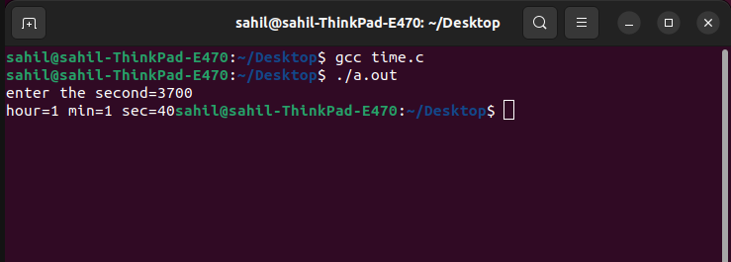

QUESTION 05
Write a program that takes seconds from the user and displays the time in days hours minutes and seconds format.
#include <stdio.h>
int main()
{
int day,hr,min,sec;
printf("enter the second=");
scanf("%d",&sec);
day=sec/86400;
sec=sec%86400;
hr=sec/3600;
sec=sec%3600;
min=sec/60;
sec=sec%60;
printf("day=%d hour=%d min=%d sec=%d",day,hr,min,sec);
return 0;
}
